Computing Project

Contents

Section 1 -Analysis 3

Introduction 3

Features Solvable by computational methods 4

Stakeholders 5

Research 6

Enter the Gungeon 6

Box Head (1&2) 7

Hades 7

Features 8

Health and Mana 8

Ammo System 8

Player 8

Boss 8

Guns 8

Art 8

Music 8

GUI 8

Settings 8

AI 8

Success Criteria 9

Musts 9

Shoulds 9

Coulds 9

Woulds 9

Temporary Notes 11

# Section 1 -Analysis

## Introduction

It is my fear that many would not be able to experience computer games as a medium for both entertainment and storytelling as games each year become increasingly more demanding on users’ systems. This is caused by a mixture of harsher hardware requirements combined with inflating prices of high-end hardware - excluding many from playing newer, modern games. Which in my opinion is a shame because I believe video games can have positive effects on its players.

A study in 2014 done by the ‘American Psychological Association’ shows that videogames can help keep the brain stimulated and develop communication and cognitive skills. However, they do also mention that games can be addictive and cause depression and aggression if played excessively. I think this is mostly caused by exploitative gameplay loops incorporated by greedy companies to keep the user for as long as possible, encouraging them to spend money on their games.

It is with these issues in mind that I have decided to make a rogue-like, top-down 2d shooter as these types of games are usually:

* not very systematically demanding
* have a fun gameplay loop
* easy to implement (so features can be further refined)

My target demographic is teenagers around the age range of 14 – 18. Having questionnaire students at my school within this age range I have found that they prefer:

* challenging games
* games that are easy to pick up
* games with a meta element to them

## Features Solvable by computational methods

Although board games are great, I want to make a computer game because I want it to include:

* dynamic ai
* real time gameplay
* dynamic visuals and graphics
* interactable environments

which are all features solvable by computational methods.

## Stakeholders

My stakeholders are:

* students around the age of 14-18
* games as a leisure activity
* my parents
* me (I need good grades)

## Research

### Enter the Gungeon

Enter the Gungeon is bullet hell, rogue-like, 2d shooter released in December of 2016 by Dodge Roll to critical acclaim.

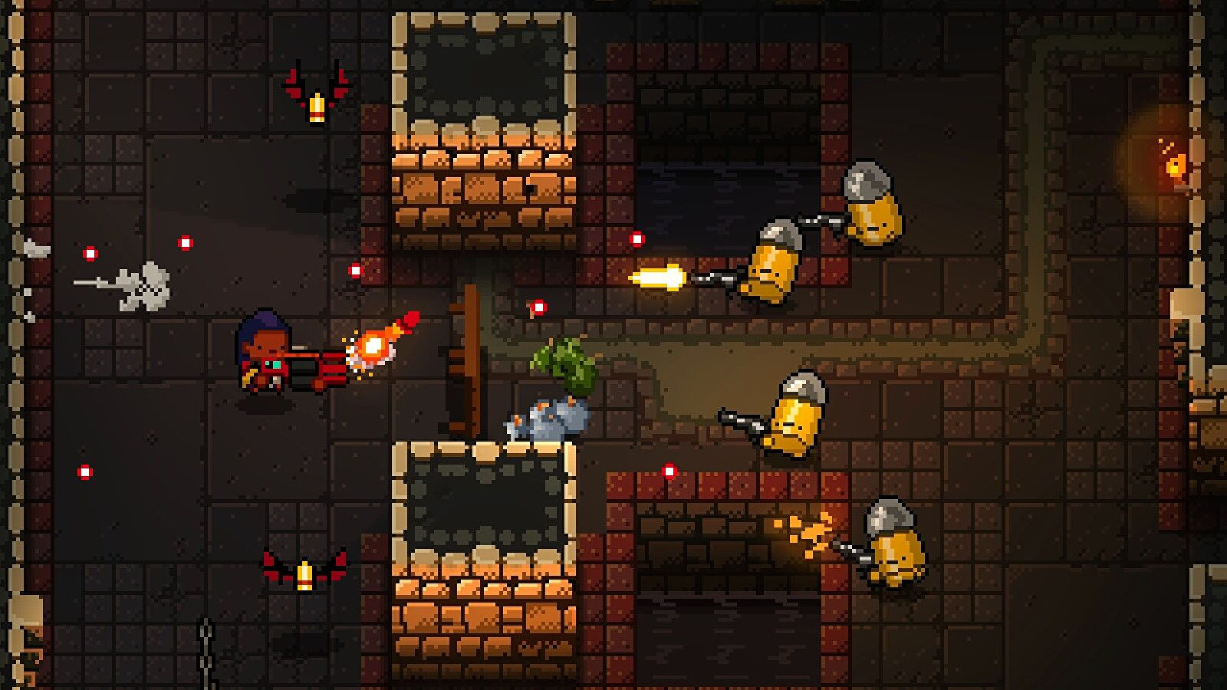

The game has many gameplay mechanics that I aim to take inspiration from including but not limited to:

* interactable environments
  + knocking over tables as cover
  + explosion barrels
  + trigger traps
  + proximity traps
* a dodge roll mechanic that leaves the player invincible for a few frames followed by a few frames of vulnerability while the player is unable to move
* a large and diverse cast of guns each to their own individual effect
* a dynamic camera that follows where the mouse is pointed

Although the game’s visual graphics looks stunning, I cannot aim to recreate it as it is not 2d- the game is made on a 3d engine called unity and only appears to be 2d through optical illusions.

## Box Head (1&2)

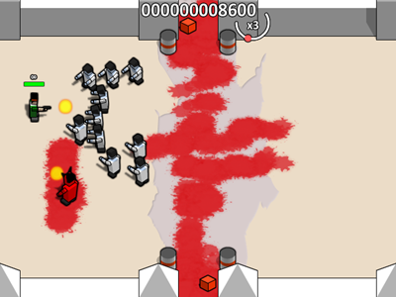Boxhead is an obscure browser video game series released on flash game websites like 7k7k and 4399, further information on this game series could not be found. The main gameplay loop of this game is killing zombies on a variety of maps where you can place explosive barrels.

I remember this game fondly for its simple but refined gameplay mechanics that mixed strategy with real-time action, a feat that I aim to recreate. The game had a simple economy system- where you had to choose to spend your money between better guns or explosive barrels. Explosive barrels could takeout hordes of zombies at once but could only be used once whilst guns would last you the entire game. You also had to be careful where you placed the barrels as if you were too close to it you would also get damaged by it. You were not the only one that could trigger the barrels as well- there were a demonic enemy type that could shoot fireball projectiles at you which would also trigger the barrels. There were also guns like the rocket launcher with limited ammo which would add further depth into the gameplay.

### Hades

haven’t finished yet- will write when finished

## Features

### Health and Mana

* Exchangeable Health and Mana system
  + You can stand still state to exchange health for mana and vice versa
  + Whilst charging your health with mana you are in a vulnerable state
  + Whilst charging your mana with health you are in a protected state where damage is halved
* Spells
  + Spells use mana to beneficial apply effects (e.g. damage to enemy, buff to the player, de-buff to enemy)

### Ammo System

* Ammo drops on player damage
* Different types of ammo for different gun types
* Some guns may use player health or mana as ammo

### Player

### Boss

### Guns

### Art

### Music

### GUI

### Settings

### AI

## Success Criteria

### Musts

1. player moves in both x and y directions
2. player faces the direction of the mouse
3. player has weapons that can be fired
4. player stops movement when faced with wall
5. map can be loaded
6. enemies are loaded onto the map
7. enemies are stopped by wall
8. enemies have ai that moves towards the player
9. enemies have ai that shot at the player when in-sight
10. player has a health bar
11. game over screen
12. main menu screen
13. UI (including: pause screen, inventory, e.c.t)
14. score counter on death screen

### Shoulds

1. some weapons have recoil- moves player in opposite direction that he fired it
2. some weapons slow player movement when being shot
3. some weapons can shoot through surfaces
4. some weapons do area damage
5. some weapons do status damage (i.e., slow, burn e.c.t)
6. player has multiple weapon types
7. player has ammo counter for each gun
8. enemies drop ammo on death
9. different ammo types (light, heavy, energy)
10. player can roll
11. enemies have recoil from being shot
12. grenades that explode on impact
13. explosion damage
14. enemy gib on explosion death
15. different enemy types

### Coulds

1. player has a throwable weapon that returns
2. magic system implemented
3. new mana bar is added
4. magic is disabled with mana is drained
5. system to exchange health points for mana and vice versa
6. environmental interaction (i.e., explosive barrels, chandeliers crashing down e.c.t)
7. bosses (Mr Cartwright, Yusuf Hassan)

### Woulds

1. map destruction
2. multiplayer
3. adding graphics and sound to the game

## Temporary Notes

Realise this isn’t important just fun to think about

Main premise of my game- The player (a student at Dulwich) battles his way through the college in order to get As from his teachers but the game begins to deteriorate the further the player progresses due the maker of the game (a Dulwich boy himself) getting progressively more stressed about doing well in his exams and takes his time away from making the game.

Probs just gonna make like 5 levels

level 1

Set in the corridor of the north block

Miss Son as end of tutorial Boss

Level 2

Set outside

gets pat-ball gun

Yusef Hassan – as a Minecraft Enderman as boss (he agreed to this)

Level 3

Set in the Shackleton Building depicted as hell

gets the custard blaster (acts as laser)

Demonised Fish and Chips as boss

Level 4

Set in the science block during a black out

Zombified students as enemies (they got food poisoning from lunch)

Mr Cartwright as Boss (angry we haven’t finished our coursework)

Level 5

Level constructed using only pygame surfaces due to student rushing to get the game finished

Olie Zhao’s Caffeine Addiction in Metaphysical form as boss (he hasn’t slept in 5 days)